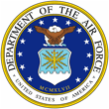 |  | 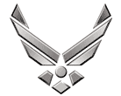

U N I T E D S T A T E S A I R F O R C E
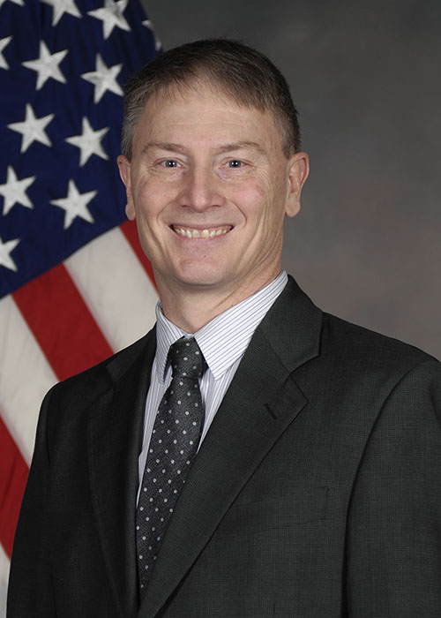
Mr. Shawn Lyman
Mr. Lyman is the Chief, Digital Sustainment, in the Office of the Deputy Assistant Secretary of the Air Force for Logistics and Product Support. He is responsible for oversight and integration of the Air Force digital transformation efforts.

Prior to moving to SAF/AQD he was the Director of Logistics, Fighters and Advanced Aircraft Directorate, Air Force Life Cycle Management Center, Air Force Materiel Command, Wright-Patterson Air Force Base, Ohio. The Directorate is responsible for the development, production, fielding, sustainment, and modernization of the Air Force fighter portfolio, which includes the A-10, A-29, F-15, F-16, F-22, and special programs; as well as the development of the Next Generation Air Dominance program and other advanced aircraft capability development activities, to include the Skyborg Vanguard program.

In previous roles Mr. Lyman was the Director of Logistics, Fighters and Bombers Directorate and before that the Product Support Manager (PSM), Helicopter Program Office, Air Force Life Cycle Management Center, Wright-Patterson AFB, OH.
Mr. Lyman served as the Acting Deputy Director, Logistics and Sustainment, Headquarters Air Force Materiel Command, Wright-Patterson Air Force Base, Ohio. His responsibilities covered all depot maintenance, supply management and sustainment transformation activities within the command. As the staff lead for logistics and lifecycle sustainment issues, he planned and coordinated product support and acquisition logistics for all fielded and emerging Air Force weapon systems.
Mr. Lyman served as Chief, Systems Integration Division, Directorate of Logistics and Sustainment. His responsibilities included Portfolio Management for 90+ command standard logistics systems. He is led the effort to develop a more robust Logistics Systems Governance process across AFMC.

Prior to moving to the Systems Integration Division Mr. Lyman was Deputy Division Chief, Centralized Asset Management (CAM) Division, Directorate of Logistics and Sustainment. He was on the core team to develop and implement the CAM processes. His responsibilities included programming, budgeting and execution of a $14B+ program for the Air Force

Mr. Lyman served as the Chief, Depot Process Improvement Branch. In that role he was a key leader of the Depot Maintenance Transformation program. Additionally, he participated in the initial development of AFSO 21 for the Air Force.

His experience includes time as the Branch Chief, Depot Maintenance Systems, Logistics Integration Division, Directorate of Logistics. He oversaw day to day operations of the AFMC Depot Maintenance Systems.

EDUCATION
MS, Logistics Management, Air Force Institute of Technology, September 1991
BS, Industrial and Systems Engineering, The Ohio State University, June 1985
CAREER CHRONOLOGY
Jul 1985 – May 1990, Industrial Engineer, Mechanized Materials Handling Branch
May 1990 – Sep 1991 Student, Air Force Institute of Technology
Sep 1991-Jan 1993 Team Lead, Logistics Action Group
Jan 1993- Sep 1998 Branch Chief, Depot Maintenance Systems
Sep 1998 – May 2003 Program Manager, Depot Maintenance Systems Division
May 2003 – Sep 2003 Chief, Depot Maintenance Systems Branch
Sep 2003 – May 2005 Chief, Depot Process Improvement Branch9. May 2005 – May 2006, HQ AFMC/A4 Lean Change Agent10. May 2006 – May 2012 Deputy Division Chief, Centralized Asset Management
May 2012 – Mar 2013 Chief, Systems Integration Division
Mar 2013 – Mar 2014, Acting Deputy Director, Directorate of Logistics, Headquarters AFMC, Wright-Patterson AFB OH
Mar 2014 – Aug 2017 Product Support Manager, Helicopter Program Office, Wright-Patterson AFB OH
Aug 2017 – Jun 2020 Director of Logistics, Fighters and Bombers Directorate
Jun 2020 – Present Director of Logistics, Fighters and Advanced Aircraft Directorate
AWARDS AND HONORS
2003 Exemplary Civilian Service Award
PROFESSIONAL MEMBERSHIPS AND ASSOCIATIONS
Armed Forces Communications and Electronic Association International, Board of Directors
PROFESSIONAL CERTIFICATIONS
Acquisition Logistics, Level III
Program Management, Level II Information Technology, Level II
(Current as of Aug 2021)

